EXECUTIVE SUMMARY
The broad intent of the NASA Mission Support Future Architecture Program (MAP) is to restructure the organization of Mission Support activities within the agency to achieve greater efficiency of resource use and to increase the quality of services provided. Simplified, MAP takes all the functions which have historically been funded and managed at each individual NASA (National Aeronautics and Space Administration) center and centralizes control of them, making each office an agency wide enterprise with branches at each individual NASA center.
The goal of this restructuring is to create synergies within mission support functions, where multiple centers could utilize the same personnel and resources, reducing redundancy in performing support activities and achieving cost efficiencies, as well as to be able to quickly and efficiently realign Mission Support to fit the needs of NASA’s key missions related to spaceflight and aeronautical research. Despite the excellent goals of MAP, there are significant risks association with its implementation, but luckily there are concrete ways to mitigate the risks of failure.

Mission Support: The Backbone of NASA

If NASA were a city, Mission Support Directorate would be the public works department. Mission Support Directorate (MSD) provides leadership, stewardship, advocacy, integration, and optimization of NASA institutional activities. NASA MSD exists to support the science and exploration missions of NASA. While other co-equal directorates within NASA focus on scientific research and space flight, MSD is focused on elements of operations that enable these functions to take place. MSD operates in support of the more glamorous directorates like the Science Mission Directorate (SMD) and Human Exploration and Operations Directorate (HEO) by providing for their Human Resources (Human Capital Management) needs, managing the complex process of procuring hardware and software necessary to conduct space flight (Procurement), security at installations (Protective Services), agency wide business operations (Shared Services Center), and management of headquarters. Additionally, MSD is responsible for Strategic Infrastructure, managing the process and budgeting necessary to maintain physical infrastructure, as well as plan and execute for future needs. (Lightfoot, 2018).

The Case for Mission Support Transformation

The reasons for such a widespread and potentially disruptive program of reorganization as MAP are partially a question of finance, and partly a question of operational efficiency. Financially, support for MSD has been under strain since the end of the shuttle program in 2012. While NASA’s overall budget has grown by almost 20% percent since the end of the shuttle program, Mission Support has fallen from 16% of the topline budget to an estimated 10% by 2024 (Horne & Weih, 2018). This budgetary environment has necessitated restructuring Mission Support to become a more fiscally (and thus structurally) efficient organization to continue support the agency.
NASA’s mission is also different in 2021 than it was in 2012. Mission Support for the shuttle program was an extremely resource intensive function. The decentralized nature of MSD services led to high fixed costs, particularly in the form of civil service labor, which makes it much harder to realign to the evolving needs of the Agency as missions transition from previous goals like supporting the International Space Station (ISS) and near-earth orbit exploration, to goals of returning to the moon and going to Mars. Additionally, the cultural and organizational dynamics of NASA have necessitated a change. All directorates within NASA tend to be managed not by direct mandate from headquarters personnel to complete a specific task in a specific period, but instead by leadership regulating processes. An individual office will have an established charter that dictates their operations, and headquarters elements will establish procedures by which that work is carried out. Headquarters restrains center activity through process, not by mandate.
This system of control by process has significant efficiency and equity gaps. Senior individuals that are responsible for determining processes for various center led activities often themselves come from the centers that they are responsible for creating processes for. Many senior leaders at NASA describe themselves as “raised at Goddard” or “brought up at Johnson,” meaning that they were hired and developed at specific centers, and obviously retain detailed knowledge of the workings of their home centers and retain loyalty to the people that still work there. Since individual centers can, and do, lobby senior headquarters personnel to tweak procedures to suit the specific roles their center is engaged in, it is often impossible to make a standardized process for the execution of Mission Support functions across the agency. This ad hoc process has led to significant inefficiency, and what many consider inequitable treatment of centers, as some centers will benefit from specialized processes, and other centers, without the support of senior leadership, must make do with the processes available to them.

NASA’s Budget Grows, but Mission Support Shrinks: How can Mission Support keep up?
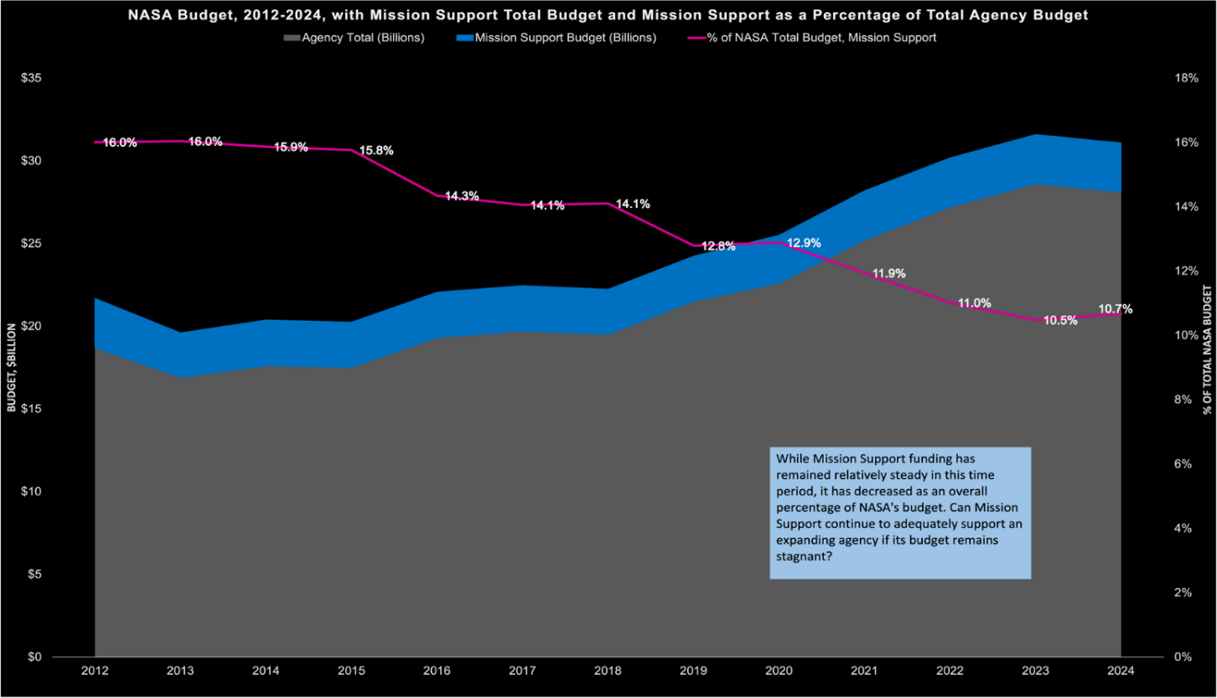

While NASA’s overall budget has grown by about 20% since 2012 Mission Support has fallen by almost 67%, indicating Congress’s unwillingness to increase Mission Support funding in its traditional structure.

Mission Support Future Architecture Program
The broad intent of the NASA Mission Support Future Architecture Program (MAP) is to restructure the organization of Mission Support activities within the agency using the enterprise structure to achieve greater efficiency of resource use and to increase the quality of services provided. Basically, MAP takes all the functions which have historically been funded and managed at each individual NASA (National Aeronautics and Space Administration) center and centralizes control of them, making each office an agency wide enterprise, with branches at each individual NASA center.
The broad intent of the NASA Mission Support Future Architecture Program (MAP) is to restructure the organization of Mission Support activities within the agency using the enterprise structure to achieve greater efficiency of resource use and to increase the quality of services provided.

The goal of this restructuring is to create synergies within mission support functions, where multiple centers could potentially utilize the same personnel and resources, reducing redundancy in performing support activities and achieving cost efficiencies, as well as quickly and efficiently realigning Mission Support to fit the needs of NASA’s key missions (Horne & Weih, 2018; Rosholt, 1966).
THE ENTERPRISE STRUCTURE IN CONTEXT
MAP is a fundamental change to the structures that make every mission the agency undertakes possible. The drastic nature of the change is reflective of the culture of the agency. It reflects the daring nature of NASA. Rather than nibble at the edges of the problem of increased cost and byzantine organization, NASA addressed the whole Mission Support infrastructure (and its parts) and changed it foundationally. This daring, reflective of an agency that launches rockets to space and is fundamentally focused on “things that make smoke and fire”, also reflects risk both to the reputation and effectiveness of the agency. Mission Support functions are the central hub of a network of activities, and all those activities within NASA rely on the work that Mission Support does to complete their own missions. If MAP does not resolve the issues of what NASA has tacitly admitted is a dysfunctional system, makes those problems worse, or creates new problems, failure of high-profile missions will ensure.
The choice to use an enterprise structure and private industry ideas of efficiency is not only reflective of NASA as an organization, but also of trends in federal government. The concept of the enterprise structure has existed within the federal government since at least the passage of the Clinger Cohen Act of 1996, which sought to reform the Information Technology capabilities of federal agencies (Graver, Stanley, 2010). The official formulation of Enterprise architecture was created for federal agencies outside of the IT community in 1999 (Federal Enterprise Architecture (FEA), 2007). The timeline of MAP creation and the greater movement to adopt Enterprise Architecture is reflective of the phenomenon Kindon refers to as “a solution in search of a problem” (Kingdon, 2001). The transition away from larger scale Mission Support structures after the end of the Shuttle Program in 2012 created a policy window for the adoption of purportedly cost saving structures, and established processes within other agencies that were applied to IT structures could then first be applied to the IT structures within NASA, then applied in a wider fashion within the agency. Despite the daring scope of the implementation of Enterprise Architecture, it is reflective of influences from outside NASA.

THE RISKS OF MAP IMPLEMENTATION
There are several significant risks associated with MAP implementation, now called transformation in MSD and NASA. The implementation of strategies designed to improve the efficiency and cost effectiveness of Mission Support is a “wicked problem”. Wicked problems are defined by the public organizational change literature as “resistant to change, having multiple possible causes, and (with) potential solutions that vary in place and time according to local context” (Rittel & Webber, 1973). The key risks I identify as most likely are:
- Centralization under the enterprise structure goes too far, and damages service delivery.
- Issues arise over the course of transformation, but MSD and NASA are too committed to the current structure and implementation strategies to effectively adjust and achieve the cost savings and efficiency goals of MAP.
- Lack of real expertise in the structure and function of service provision at the local level creates so much confusion at higher levels that new inefficiencies replace old inefficiencies, eliminating the benefit of the change.
- The lack of clear quantitative goals for MAP transformation will make evaluation of the program impossible and make it impossible to effectively adjust the program when necessary.
MITIGATING THE RISKS OF MAP IMPLEMENTATION
Existing literature on organizational change indicates that approximately 70% of attempts fail (Burnes & Jackson, 2011). It is perhaps unhelpful to think of the future of transformation as a binary choice of success or failure. Instead, it is better to address these potential risks to increase the amount of successful implementation that can be affected by MAP: “failure is rarely unequivocal and absolute… even policies that have become known as classic policy failures also produced small and modest successes” (McConnell, 2015).
There are steps that can be taken to reduce the potential harm to the success of MAP transformation these risks represent. First let’s list these interventions, then discuss how they connect to individual risks:
- Inclusion of “street level bureaucrats” into the stakeholders for MAP, generating active collaboration with all levels of authority within enterprise structures.
- Acceptance of variation in levels of enterprise integration at the center level.
- Evidence based evaluation: establishing clear priorities and goals, performance monitoring, and transparency within the NASA community on what the data says about the effectiveness of MAP.
MAP IMPLEMENTATION: CURRENT STATUS AND THE FUTURE
The good news is that MSD and NASA have already begun to institute some of the structures necessary to address these risks. In the past few weeks, an office dedicated to Enterprise Operations has been stood up, drawing staff from centers across the agency, with the intent to coordinate enterprise level integration with center level functions across NASA. This inclusion of the “street level bureaucrat” into the transformation process will, if effectively utilized, create a valuable bottom-up point of view that has the potential to “connect actors vertically and horizontally in a process of collaboration and joint deliberation” (Ansell et al., 2017). Attempts like these, of collaborative policy implementation, can help reduce the risk of over-centralization, and provides a valuable voice of real-world expertise, which can help reduce the chances of “churn” created by incomplete or imperfectly executed implementation, and reduce the risk of replacing the old inefficiencies of legacy structures with new ones. What remains to be seen, however, is if the valuable street level expertise of these individuals, and others across NASA, will be integrated into transformation. The structure is in place to make this a reality, but whether this function is used by senior leaders and allowed to have an effect is yet to be determined.
There is also an office within MSD that is dedicated to assessing the effect of MAP on the efficiency of enterprise provided services. The Transformation Office is challenged in its ability to effectively provide evaluation of MAP, namely because of a lack of established and quantified goals that tell us what success looks like. While it certainly isn’t impossible for MAP to be successful without a clearly defined and transparent set of quantified goals for efficiency and cost reduction, it has been exhaustively proven that well defined and transparent goals make policy formulation and implementation more successful (Gold et al., 2015). Development of these goals should and creating a process by these goals and data related to them are disseminated regularly will greatly increase MAP’s chances of success.
There are some encouraging signs that actual implementation of the transformation will be varied by situation at the margins in the development of new forms of service delivery, indicating that there is a certain level of acceptance that “an intervention that is successful in one location does not necessarily (or even routinely) deliver the same results elsewhere” (Braithwaite et al., 2018). The surest way to ensure that this allowance of variation will take hold is the level to which collaborative implementation, and local autonomy, takes hold throughout the agency. A more formalized means of ensuring a level of local autonomy is essential to ensuring the agility necessary to make transformation successful.
No one is hired, no object is purchased, and not a single dollar of congressionally appropriated funds is spent without the active participation of one or several of Mission Support’s diverse offices.

There is a danger of, while proposing potential improvements to MAP, painting too dire a picture of transformation in its current state. We risk engaging in unhelpful binary thinking, where the suggestions above are the only savior of MAP, and if they aren’t implemented failure will ensue. The purpose of these recommendations is to enhance the effectiveness of the MAP, not save it from destruction. It is very encouraging that there are already early signs of some of these recommendations already being taken up within MSD independent of this paper. To condense my recommendations down, increasing the effectiveness of MAP comes down to 3 things: increasing the level of collaborative policy making and implementation across all levels of authority withing MSD and the enterprises, trusting the experience and knowledge of those who have been tasked with grassroots level implementation and allowing them some autonomy in how MAP is implemented at the ground level, and creating and disseminating clear measures both of what MAP should do and how it is actually doing.
Why MAP Matters
Mission Support Directorate, and the Mission Support Theme in general, encompasses a wide variety of processes, personnel, and requirements. Its responsibilities are central to the success of all of NASA’s missions. No one is hired, no object is purchased, and not a single dollar of congressionally appropriated funds is spent without the active participation of one or several of Mission Support’s diverse offices.
Mission Support is currently at a critical inflection point in its history. Mission Support Future Architecture Program (MAP) has been instituted across the agency and is in the process of being fine-tuned to achieve the efficiency and increased support capacity it has promised. Higher authorities in Congress and the Executive branch have consistently signaled that they are unwilling to increase the funds available to support MSD and MES (Mission Enabling Services) in substantial amounts. NASA, and Mission Support, now must follow through on the goals of MAP, or risk the consequence of a failed implementation, as measured in degraded service by Mission Support, and the damage to highly prized projects like Artemis, America’s return to the moon, which will be the first time a woman and person of color have touched its surface (Dunbar 2021, Mission Support Directorate 2018, Shea 2015).

WORKS CITED
Horne, M., & Weih, T. (2018). Mission Support Future Architecture Program Center Roadshow.
Kingdon, J. W. (2001). A MODEL OF AGENDA-SETTING, WITH APPLICATIONS. Law Review, 2, 9.
Mission Support Directorate. (2018). MSD Roles and Responsibilities. Https://nodis3.gsfc.nasa.gov/NPD_attachments/CommonRoles_October2018.pdf
Brian Dunbar. NASA - FY 2012 Budget Estimate. (2021). [Other]. https://www.nasa.gov/news/budget/2012.html
Rosholt, R. L. (1966). An Administrative History of NASA, 1958-1963 (p. 411). NASA Scientific and Technical Information Division.
Shea, G. (2015, August 12). About Us [Text]. NASA. http://www.nasa.gov/msd/aboutus
The White House. Ansell, C., Sørensen, E., & Torfing, J. (2017). Improving policy implementation through collaborative policymaking. Policy & Politics, 45(3), 467–486. https://doi.org/10.1332/030557317X14972799760260
Braithwaite, J., Churruca, K., Long, J. C., Ellis, L. A., & Herkes, J. (2018). When complexity science meets implementation science: A theoretical and empirical analysis of systems change. BMC Medicine, 16(1), 63. https://doi.org/10.1186/s12916-018-1057-z
Burnes, B., & Jackson, P. (2011). Success and Failure in Organizational Change: An Exploration of the Role of Values. Journal of Change Management, 11(2), 133–162. https://doi.org/10.1080/14697017.2010.524655
Federal Enterprise Architecture (FEA). (n.d.). The White House. Retrieved November 22, 2021, from https://obamawhitehouse.archives.gov/node/17927
Gold, J., Institute for Government (Great Britain), & Mowat Centre for Policy Innovation. (2015). International delivery: Centres of government and the drive for better policy implementation. http://www.deslibris.ca/ID/244572
Graver, Stanley. (2010). Why Doesn’t the Federal Enterprise Architecture Work? Technology Matters, Inc.
Horne, M., & Weih, T. (2018). Mission Support Future Architecture Program Center Roadshow.
Kingdon, J. W. (2001). A MODEL OF AGENDA-SETTING, WITH APPLICATIONS. Law Review, 2, 9.
McConnell, A. (2015). What is policy failure? A primer to help navigate the maze. Public Policy and Administration, 30(3–4), 221–242. https://doi.org/10.1177/0952076714565416
Mission Support Directorate. (2018). MSD Roles and Responsibilities. https://nodis3.gsfc.nasa.gov/NPD_attachments/CommonRoles_October2018.pdf
NASA - FY 2012 Budget Estimate. (2021). [Other]. Brian Dunbar. https://www.nasa.gov/news/budget/2012.html
Rittel, H. W. J., & Webber, M. M. (1973). Dilemmas in a general theory of planning. Policy Sciences, 4(2), 155–169. https://doi.org/10.1007/BF01405730
Rosholt, R. L. (1966). An Administrative History of NASA, 1958-1963 (p. 411). NASA Scientific and Technical Information Division.
Shea, G. (2015, August 12). About Us [Text]. NASA. http://www.nasa.gov/msd/aboutus

